Deliverable 6.1.4:
Development Report of the Human Swarm Interaction in Guardians Project

Authors:

Amir Naghsh and Chris Roast

15th December 2008

Introduction
This report describes the development process of a human robot interface for a swarm of autonomous robots assisting the process of search and rescue as carried out by fire fighters.
The human robot interfaces that are examined in this report should operate in a setting that is oppressive and operationally demanding for humans. The scenario of fire incident in Guardians project is based upon a fire in large single story warehouse. Such warehouses are usually as large as (400 x 200) m² and in an incident can become filled with smoke and fumes. There have been notorious tragic examples where fire-fighters lost life during search and rescue. In the most recent tragedy in November 2007, four fire fighters were killed in a vegetable warehouse blaze in Warwickshire.
When attending a fire incident, fire fighters are concerned primarily with assessing risk to life resulting from the fire and where necessary this may involve searching the warehouse during the incident. The potential for robot support for the search and rescue is high. However there are some significant challenges for fire fighters involved in search and rescue to work effectively with robots.
- The search environment of an incident is highly oppressive and fire crew operations can be impaired through: poor visibility due to smoke; poor tactile awareness due to safety-clothing; and limited hearing due to fire fighters headgear and ambient noise. This presents ergonomic and communicative design problems for any direct human robot interactions.
- Fire fighters operate with established protocols to ensure mutual safety, it is important that robot behaviours complement these protocols, enhancing some search and rescue tasks and not disrupting others.
- Fire fighters engaged in search and rescue are working under considerable mental and physical stress. This means human robot interaction tasks could easily become too complex in the setting described.
These factors also influence our approach in designing human robot interfaces. Recommended good design practice of user centred design is limited:
- The dedicated access to domain experts is limited as fire fighters are normally required to be available for emergency response while at work;
- Understanding the context of use is particularly hard, it is both high risk and highly skilled;
- For the same reasons, the context of use is demanding, varied and unpredictable, thus limiting any realistic experimentation and evaluation process;
- Complementing these points, early development processes are also complicated by the end users not necessarily understanding the capability and competences of robot technology.
In order to address these points the approach that has been followed is for the development team closely engage with fire fighters and employ interviews, questionnaires and available documentation to develop an understanding of their technical requirements [1]. For user centred concerns low fidelity prototypes have been employed as a means of engaging with the domain experts. These have served mainly as the focus for participatory design input as opposed to more formal assessment.

Conceptual Design
The problem setting concerns how fire fighters working in a search and rescue are to understand and benefit from the robot swarm that are also present at the incident. The technical objectives of the robot swarm are to support fire fighting by in effect being ahead of the fire fighters and helping inform them about obstacles, suitable pathways to take and also potentially dangerous fumes and toxic gases and their volatility [3][2].
The governing concern in the design process was to ensure that the robot behaviour and human robot interaction represented a minimal additional mental and/or communication load for fire fighters. Based on this, the conceptual model of the fire fighter being treated as an exceptional swarm member was developed. The exceptional features being the predominance of the fire fighter in terms of autonomy, skill and authority. In terms of interaction, this meant that the robots will in effect surround the fire fighter and move with them.
In cases where the robots identify hazards or specific safe routes they provide information for the fire fighter to employ and act on at their discretion. This conceptual model of HRI for swarms poses a number of questions about how to inform the fire fighters about potential hazards and potential safe routes to follow in highly oppressive and stressful situations.
In formulating the problem the fire fighters were consulted and shown likely or possible configurations using a simple display desktop based prototype. The prototype simply illustrated possibilities and also animated the intended robot operations through a number of animated storyboards (in Power point). Through this consultation a peripheral visual display was chosen as the most appropriate means of helping direct fire fighters.
A simple prototype was then developed to enable experimentation with alternative means of helping direct fire fighters [Roman 2008]. A number of alternative approaches to visually depicting directions to the fire fighters were considered. These included:
- An analogical view where the light array is used to depict a direction directly. That is the angle of the illuminated light is computed to be the angle to the views head for the safe direction. The benefit of this is approach is that it unlikely to require any effort to interpret. If in doubt the fire fighter can simply follow the light. Specific questions for which this approach needs to be refined concern the number of lights used represent the direction and the effective resolution in terms of number lights, light intensity and angular accuracy.
- A logical view where the light array is used to portray encoded commands to the fire fighter. At face value this has the potential to further burden the fire fighter as they'll have to interpret the encoded commands. Specifically this approach is likely to be more mentally demanding. The questions to be answered about such an approach concern identifying the appropriate command language and its portrayal.
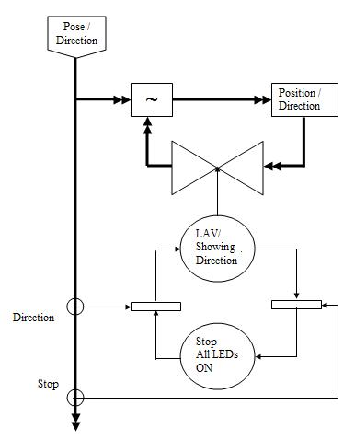
Figure 1 Outline design for analogical visor
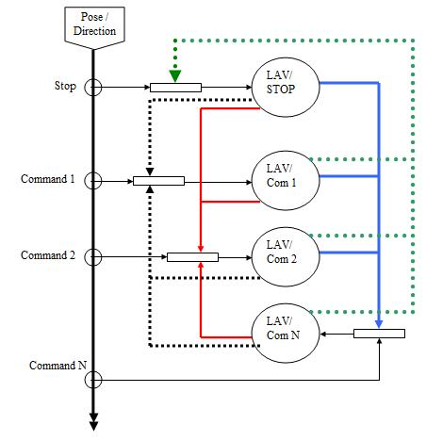
Figure 2 Outline design for logical visor
To characterise the design of these two possibilities, a graphical notation called Flowent is used for design representations [4]. Figure 1 represents the first possibility where there are two interaction states. One state represents "moving", that is where the direction is presented on the light array visor in an analogical view. The other state represents "stop" this is presented to the user by all the lights being turned on. The transition from "stop" to "moving" states is triggered by the swarm collectively identifying a direction for the fire fighter to follow. When the swarm require no further movement the transition to "stop" is enabled. Figure 2 illustrates the second possibility where the direction is shown as specific commands to the fire fighter. In this case it can be seen that specific commands are associated with individual states.

Light Array Visor (LAV)
The swarm of robots determine a direction that fire fighter has to follow taking into account the fire fighter position, the position of possible obstacles that have to be avoided and the destination position. Based on this information and the fire fighters pose the direction to be taken is calculated and visually illustrated to fire fighter. This section explains the LAV prototype which was developed to visually illustrate the navigational information to the fire-fighter.
LAV is consisted of a number of LED lights which are mounted on a safety mask as it can be seen in Figure 3. In order to collect the required data from the swarm of the robot, the fire-fighter carries a PC in a backpack. The PC communicates with the robots through a wireless network and it is also used to connect to an IMU sensor as well as LAV. IMU sensor is placed on the fire-fighter's back where it is used to detect fire-fighter's orientation. LAV is connected to the PC through a Phidget interface board which is also placed in the fire-fighter's backpack. Figure 3 illustrates the hardware on fire-fighter and how they are connected to each other. All the connections are wired.
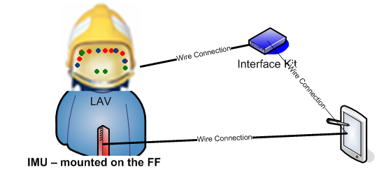
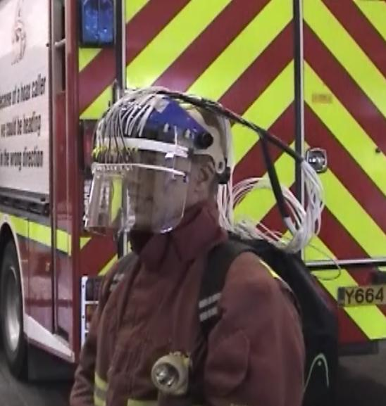
Backpack

Figure 3 Hardware equipment on Fire-Fighter

Experiments and Results
In order to assess the use of the alternative designs in a realistic setting a trial of a more realistic prototype was developed and conducted with fire fighters.
A range of easily configurable versions of the two alternatives described above were prototyped to operate with the light array visor, for assessment with fire fighters at their fire station. At this stage in the project an operational robot swarm is not full developed hence the prototype was used to simulate robot swarm guidance to the fire fighter. The same prototype could also be operated by the experimenter for live direction control, hence providing a wizard-of-oz style set-up.
In this section, we only explain some of the findings from our previous study and more details on the trail plan and experimental results can be find at [2].
The findings from the study were somewhat of a surprise. The analogical interface appears in principle to be simplistic and intuitive and thus easily adopted. However, this was not the case. The clear encoding of directions was preferred by the fire fighters, despite the basic theory being that it is likely to involve more effort.
Conceptually there appears to be a distinction between two ways of interpreting lights on at particular angle in the light array. One is that the lights are an instruction to move that way, the other is that the lights are a representation where you need to head. The fire fighters appeared to prefer the former of these two.
A more general point that may also be an influence is that fire fighters are not like everyday users. They are highly skilled experts and as such may have a different perspective upon the use and value of tools. Within the fire incident the tools used have to be reliable and well understood by the fire fighting team. Communication channels tend to be precise, clear and well organised. In such a setting the expectation is that tools operate in a clear and well defined manner, and the simplest clear account of employing the light array in this manner is for it to be logical in its style.

Conclusion
In this report, we described the development processes adopted for effective human centred design in the context of developing a human robot interface. The human robot interactive setting is that of a swarm of autonomous robots assisting the process of search and rescue as carried out by fire fighters. The conclusion from the study illustrate that the complex nature of professional practice in the high risk settings has significant influences upon the fitness for purpose. Furthermore, a second version of the light array visor has been developed which is integrated into the actual fire-fighter visor. Further HRI devices will also be developed to be used in future experiments with fire-fighters.

References
- Naghsh, A. M., Gancet, J., Tanoto and Roast, C. R. (2008) Analysis and Design of Human-Robot Swarm Interaction in Firefighting, in the Proc. Of IEEE Conference of Robot-Human Interactions (RO-MAN), Munich, Germany.
- Naghsh, A. M. and Roast, C. R. 2008. Designing user interaction with robots swarms in emergency settings. In Proceedings of the 5th Nordic Conference on Human-Computer interaction: Building Bridges (Lund, Sweden, October 20 - 22, 2008). NordiCHI '08, vol. 358. ACM, New York, NY, 519-522. DOI= http://doi.acm.org/10.1145/1463160.1463234
- Penders, J., Cervera, E., Witkowski, U., Marques, L., Gancet, J., Bureau, P., Gazi, V. and Guzman, R. (2007) Guardians: a swarm of autonomous robots for emergencies. In Workshop of Robotics in Challenging and Hazardous Environments in ICRA2007.
- Smith, A. P. (2006) Exploring the Specification of Haptic Interactions. In Proc. Of DSV-IS 2006, Dublin, Ireland.

http://news.bbc.co.uk/2/hi/uk_news/7078743.stm

